1. Read Cars Data
2. Total Cars: To get a count of total records
3. The manager asked the employee, how many cars will be available in 2019?
4. The manager asked the employee How many cars will be available in 2016,2017,2018?
5. Client asked me to print the total of all cars by year. I don’t see all the details.
6. Client asked to car dealer agent, how many diesel cars will be there in 2020?
7. Client asked to car dealer agent, how many petrol cars will be there in 2020?
8. Manager asked me to print all the fuel cars (Petrol,diesel, and CNG) come by all year
9. Manager said there were more than 100 cars in a year, which year had more than 100 cars?
10. Manager said, all cars count details between 1998 and 2019, we need complete list
11. What is the total count of used cars in the dataset?
12. What are the unique car brands available in the dataset?
13. How many cars of each brand are available in the dataset?
14. What is the average selling price of used cars in the dataset?
15. What is the maximum and minimum selling price of used cars in the dataset?
16. Which car has the highest selling price, and what are its details (brand, model, etc.)?
17. How many cars have manual transmission, and how many have automatic transmission?
18. What is the average mileage of used cars in the dataset?
19. What is the distribution of fuel types among the used cars (e.g., petrol, diesel, CNG)?
20. How many cars are available in each year of manufacture?
21. What is the average age of the used cars in the dataset?
22. How does the selling price vary with the age of the car?
23. What are the top 5 most expensive cars in the dataset?
24. What are the top 5 cheapest cars in the dataset?
25. Is there any correlation between mileage and selling price of used cars?
26. How many cars are available in each location (city)?
27. Which location has the highest number of used cars listed?
28. What is the average selling price of cars in each city?
29. How does the selling price vary with the number of previous owners?
30. What is the distribution of car seats among the used cars (e.g., 4-seater, 5-seater, etc.)?
31. 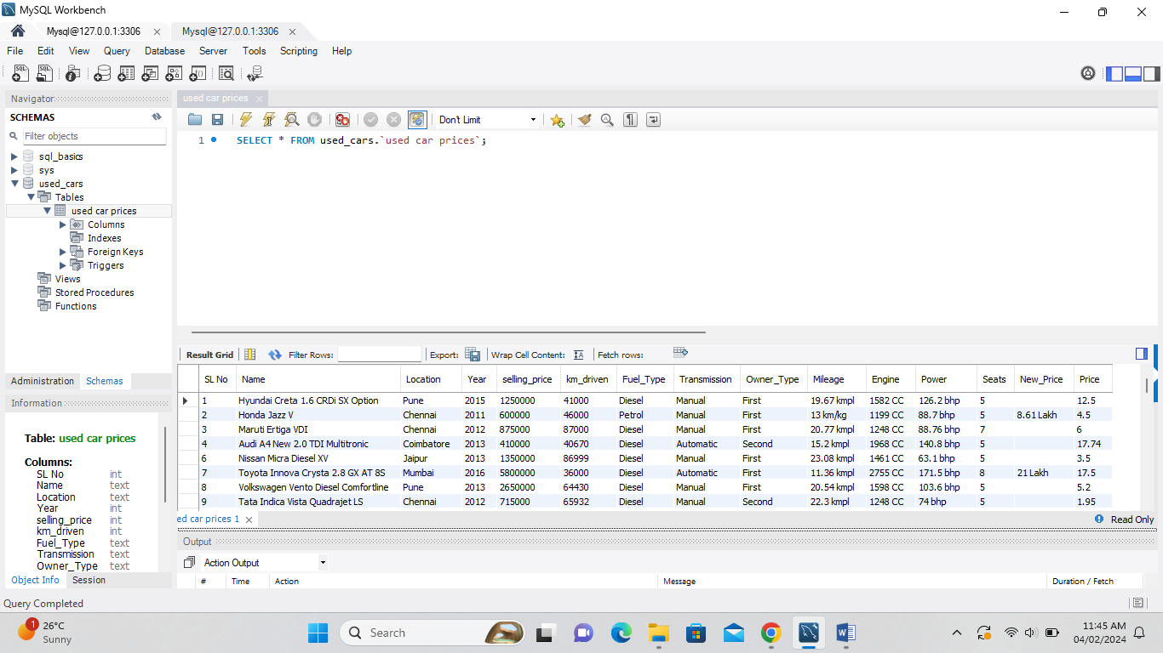
32. 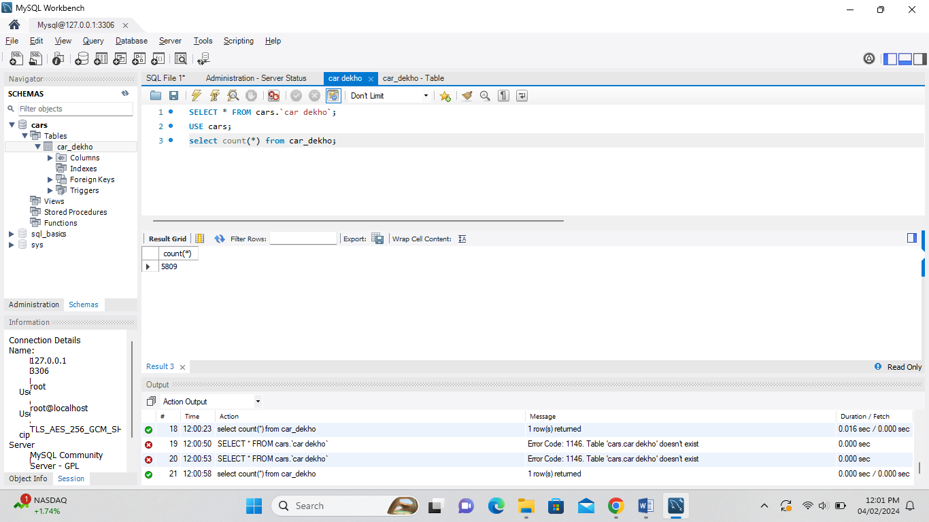
33. 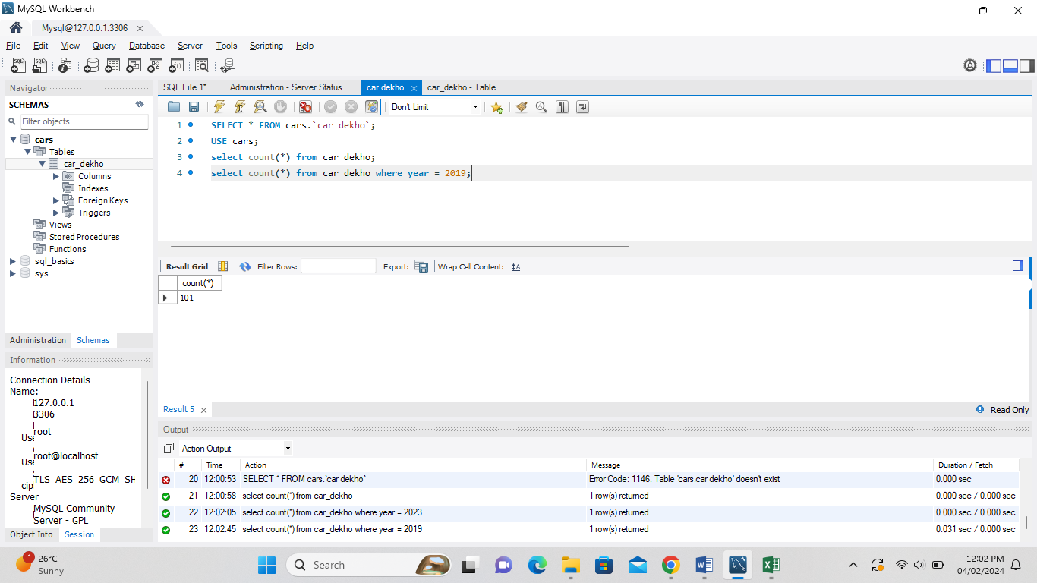
34. 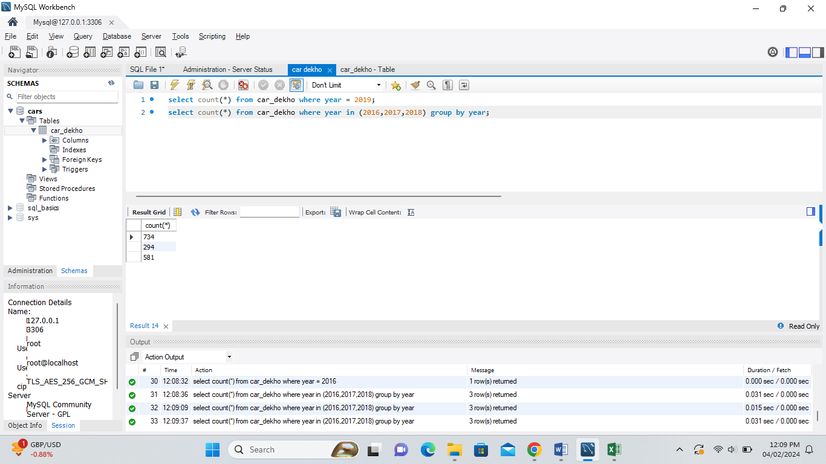
35. 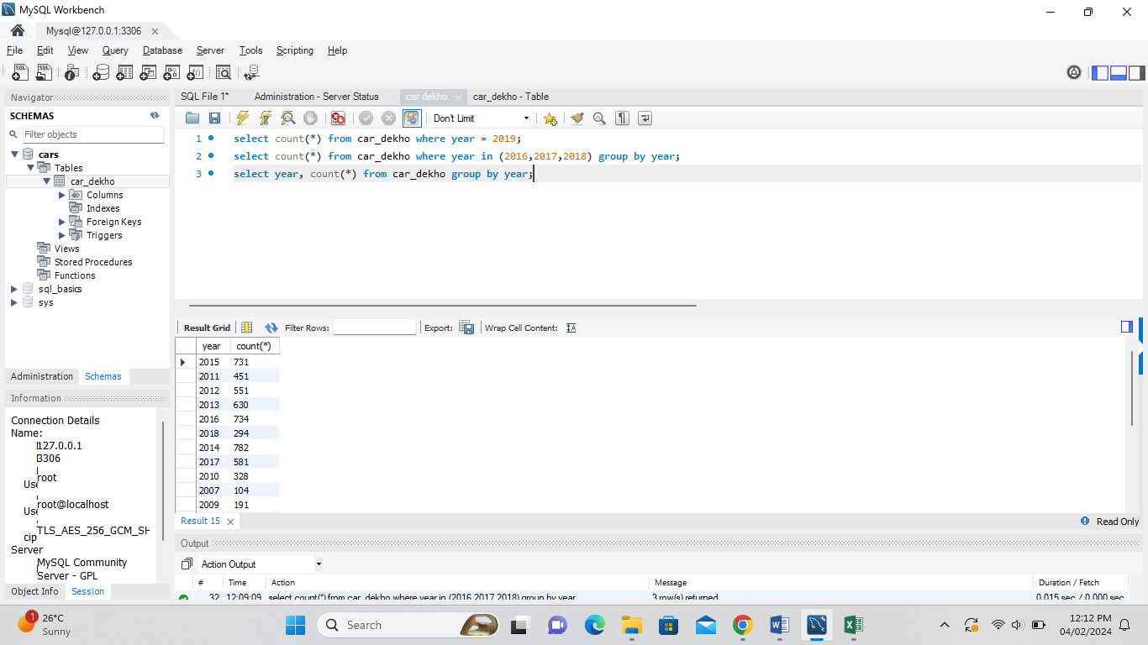
36. 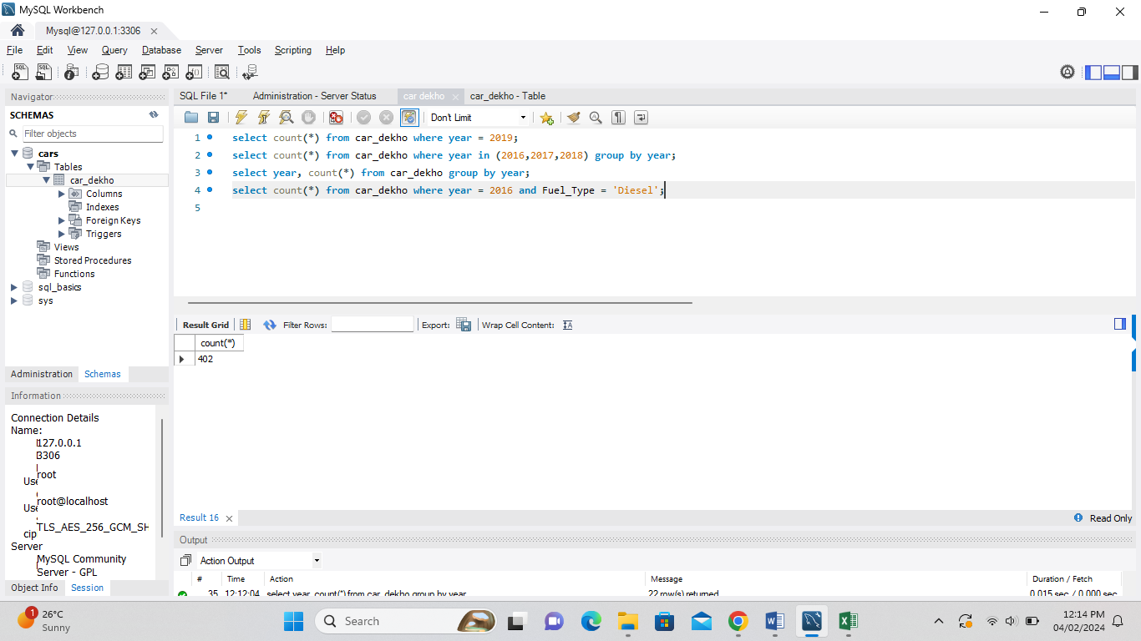
37. 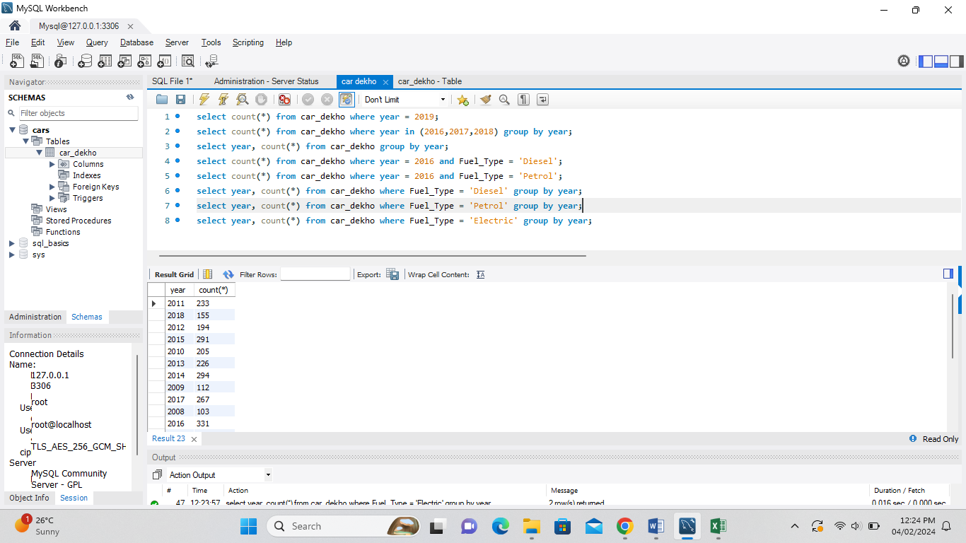
38. 